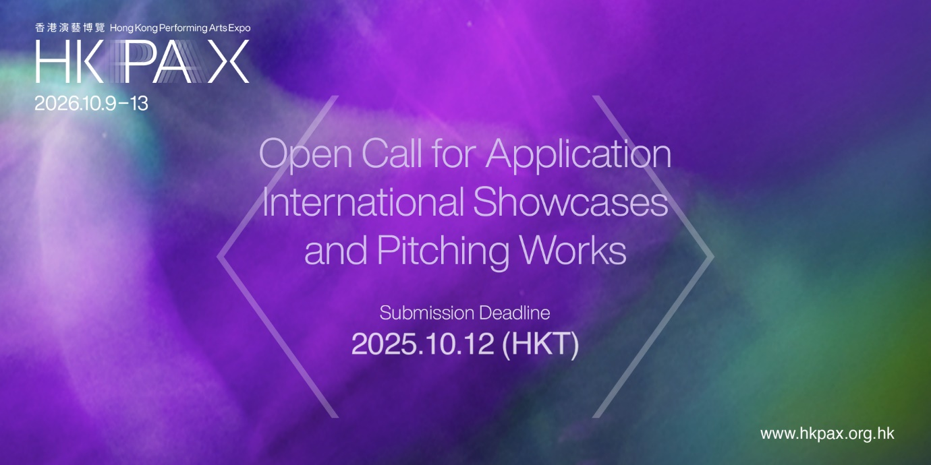

***Short version***

**[OPEN CALL] Hong Kong Performing Arts Expo 2026**

**Applications for International Showcases and Pitching Works Now Open**

**Submission Deadline: 12 October, 2025**

As a vibrant East-meets-West welcoming hub in the global performing arts community, the 2nd edition of the Hong Kong Performing Arts Expo (HKPAX) returns from 9 to 13 October 2026. Ready to take the stage in Hong Kong and expand network with new markets particularly in China and across Asia? Artists and organisations worldwide are now invited to apply!

**International Showcases**

* Featuring full-length performances in dance, drama, music, *xiqu* (Chinese Opera), and multi-disciplinary arts (excerpt performances are allowed for *xiqu*’s work).
* Performance duration must be between 45 to 60 minutes.
* Submissions may include ready-to-tour work or newly created works. However, works-in-progress will NOT be accepted.
* Selected applicants will receive a showcase venue with basic technical and promotional support, and an allowance of US$10,000.

**Pitching Works**

* Pitch original projects to a network of presenters, venues, producers, and agents
* Submissions may include ready-to-tour works, works that are in-planning for a premiere within the next two years, and work-in-progress productions are allowed
* Selected applicants will be given 15 minutes to present to the HKPAX community, including a 10-minute presentation and a 5-minute Q & A session.

All selected applicants will be offered a complimentary spot in the HKPAX exhibition area to promote their works, and two Full Passes granting access to all HKPAX events from 9 to 13 October 2026!

**Submission Deadline:** 12 October 2025, 23:59 (GMT+8)

**Apply NOW:** <https://www.hkpax.org.hk>

**Socials:** [hkpax.official](https://linktr.ee/hkpax.official) (facebook/instagram/LinkedIn/Youtube/Wechat)

**About Hong Kong Performing Arts Expo**

Initiated by Hong Kong Arts Development Council, HKPAX provides regional and international arts professionals with valuable opportunities to broaden their networks, explore partnership and touring opportunities with artists, presenters, venues, producers, and agents from around the world. Heartfelt thanks to the global HKPAX community, the inaugural HKPAX in 2024 welcomed over 1,600 arts leaders and practitioners from a wide span of 60 regions and countries and attracted over 32,000 attendees and audiences in the city.

**Get Ready for HKPAX 2026!**

Registration will open in April/May 2026, when the full programme of HKPAX will be unveiled. In the meantime, please be invited to explore some preliminary registration information [here](https://www.hkpax.org.hk/page/registration-guide), which can help you plan your journey to HKPAX, alongside a glimpse of the programme overview [here](https://www.hkpax.org.hk/page/programmes).

**[OPEN CALL] Hong Kong Performing Arts Expo 2026**

***Long version***



**Applications for International Showcases and Pitching Works Now Open**

**Submission Deadline: 12 October, 2025**

As a vibrant East-meets-West welcoming hub in the global performing arts community, **the second edition of the Hong Kong Performing Arts Expo (HKPAX) returns from 9 to 13 October 2026**. Ready to take the stage in Hong Kong and expand network with new markets particularly in China and across Asia? Artists and organisations worldwide are now invited to **apply for its International Showcases and Pitching Works!**

Initiated by The Hong Kong Arts Development Council (HKADC), HKPAX provides regional and international arts professionals with valuable opportunities to **broaden their networks, explore partnership and touring opportunities** with artists, presenters, venues, producers, and agents from around the world. The inaugural HKPAX in 2024 welcomed over 1,600 arts leaders and practitioners from a wide span of 60 regions and countries and attracted over 32,000 attendees and audiences in the city.

HKPAX 2026, from 9 to 13 October 2026, will feature a thoughtfully curated programme spanning multiple strands, including International Showcases, Pitching Works, Hong Kong Chapter, Conversations, Exhibition, Networking Events, Expo Programmes, and more, making it a catalyst for new partnerships and a gateway to the vibrant arts scene in China, including Hong Kong, Asia and beyond. The open call for International Showcases and Pitching Works is now underway and will **close at 23:59 (Hong Kong time) on 12 October 2025**.

**International Showcases** presents **full-length performances** in dance, drama, music, *Xiqu* (Chinese Opera), and multi-disciplinary arts, with a duration of 45-60 minutes, before local and international audiences in Hong Kong’s major performance venues. Selected applicants will be provided with **a showcase venue** with basic technical and promotional support, and **an allowance of US$10,000** towards travel and accommodation expenses.

**Pitching Works** offers artists and arts groups from around the world the chance to **pitch their original projects** to presenters, venues, producers, and agents — creating business opportunities and space for co‑development of new works. Selected applicants will be given **15 minutes to present** to the HKPAX community, including a 10-minute presentation and a 5-minute Q & A session.

Both selected applicants of International Showcases and Pitching Works will be offered a **complimentary spot** in the HKPAX exhibition area to promote their works, and **two Full Passes** granting access to all HKPAX events from 9 to13 October 2026!

**Apply NOW:** [**https://www.hkpax.org.hk**](https://www.hkpax.org.hk)

To learn more about the programme of HKPAX 2026 and Open Call tips, remember to join our briefing session on 17 September 2025 — follow our social media for the latest updates!

Follow and subscribe to HKPAX for the latest news and updates:

* Facebook: <https://www.facebook.com/hkpax.official> *(@hkpax.official)*
* Instagram: <https://www.instagram.com/hkpax.official> *(@hkpax.official)*
* LinkedIn: <https://www.linkedin.com/company/hkpaxofficial>
* Wechat: *@HKPAXofficial*
* YouTube: <https://www.youtube.com/@hkpax.official>
* Subscribe: <https://bit.ly/3KXJmOP>

**Discover the exciting possibilities of HKPAX 2026**

**on the next page…. Get Ready for HKPAX!**

Registration will open in April/May 2026, when the full programme of HKPAX will be unveiled. In the meantime, please be invited to explore some preliminary registration information below to help you plan your journey to HKPAX. Be sure to read the registration guide [here](https://www.hkpax.org.hk/page/registration-guide) to plan your trip in advance!

|  |  |
| --- | --- |
| HKPAX 2026 Programmes at a Glance! | |
| International Showcases | A series of sensational and innovative productions, carefully selected from global submissions, take to the stage in Hong Kong to showcase groundbreaking creativities by artists across the world. |
| Pitching Works | A platform for international artists and performing arts troupes to pitch their original projects to presenters, producers, agents, venues, funding bodies, curators, and arts professionals, exploring business opportunities and identifying potential partners worldwide. |
| Conversations | Arts and cultural leaders, artists, and producers from around the world share their perspectives and professional insights on current issues in the performing arts industry, igniting creativity and driving the industry forward. |
| Exhibition | A place for international delegates to meet, connect, exchange ideas, or simply chat with other HKPAX participants about their companies, works, projects or potential business opportunities, - all within a relaxed exhibition setting. |
| Hong Kong Chapter | An exceptional chance to enjoy a feast of Hong Kong arts through a dynamic series of presentations by local independent artists and small and medium-sized arts groups - showcasing their artistic visions, evolving creative ideas, practices, and mature works. |
| Networking Events | From structured networking activities, interactive breakout sessions, to evening gatherings, these events offer valuable opportunities for participants to expand their connections and cultivate meaningful partnerships. |
| Expo Programmes | A rich spectrum of supporting programmes presented by Hong Kong's major performing arts groups and venues that fully showcase Hong Kong's dynamic performing arts scene. |
| Cultural Offerings | Special cultural experiences during the HKPAX period allow participants to immerse in the city’s unique blend of Asian and Western traditions and cultural ambience. |